Objectives:

* Classes and Objects

This homework assignment is based on Chapter 10. It is recommended to complete the class exercise first before starting the homework assignment.

There are three projects, each worth 33.3%

**Project #1**

**#1 Print screen the input/output with the code below here.**

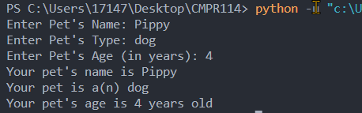

Code:

class Pet:

#Mutator attributes

def set_name(self, value):

self.__name = value

def set_animal_type(self, value):

self.__animal_type = value

def set_age(self, value):

self.__age = value

#Assessor attributes

def get_name(self):

return self.__name

def get_animal_type(self):

return self.__animal_type

def get_age(self):

return self.__age

def main():

mypet = Pet()

mypet.__name = input("Enter Pet's Name: ")

mypet.__animal_type = input("Enter Pet's Type: ")

mypet.__age = input("Enter Pet's Age (in years): ")

print(f"Your pet's name is {mypet.__name}")

print(f"Your pet is a(n) {mypet.__animal_type}")

print(f"Your pet's age is {mypet.__age} years old")

main()

Project #2

**#2 Print screen the input/output with the code below here.**



Code:

class Employee:

def __init__ (self, name, id_no, department, jobtitle):

self.name=name

self.id_no=id_no

self.department=department

self.jobtitle=jobtitle

def get_employee_info(self):

msg = f"Name: {self.name}\tID Number: {self.id_no}\tDepartment: {self.department}\tJob Title: {self.jobtitle}"

return msg

def main():

employee1 = Employee("Susan Meyers",326558,"Finance/Acct","Vice President")

employee2 = Employee("Mark Jones",254877,"IT/Software Dev","Programmer")

employee3 = Employee("Joy Rogers",326588,"Manufacturing","Assembler")

print(employee1.get_employee_info())

print(employee2.get_employee_info())

print(employee3.get_employee_info())

main()

**Project #3**

**#3 Print screen the input/output with the code below here.**

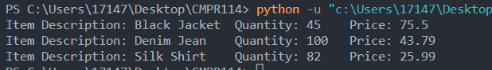

Code:

class RetailItem:

def __init__(self, itemdesc, qty, price):

self.item_descirption = itemdesc

self.quantity = qty

self.price = price

def get_item_info(self):

msg = f"Item Description: {self.item_descirption}\tQuantity: {self.quantity}\tPrice: {self.price}"

return msg

def main():

item1 = RetailItem("Black Jacket", 45, 75.50)

item2 = RetailItem("Denim Jean", 100, 43.79)

item3 = RetailItem("Silk Shirt", 82, 25.99)

print(item1.get_item_info())

print(item2.get_item_info())

print(item3.get_item_info())

main()

**Submit this document to Module 4 Homework.**